

**Year 11 ATAR Human Biology**

**Task 6: Foetal Development**

**Investigation**

Time Allocated: 50 minutes

Weighting 10%

|  |  |  |  |
| --- | --- | --- | --- |
| **Name:** | **Teacher:** Miss Cunningham | **Date:** | **Score:**  /25 |

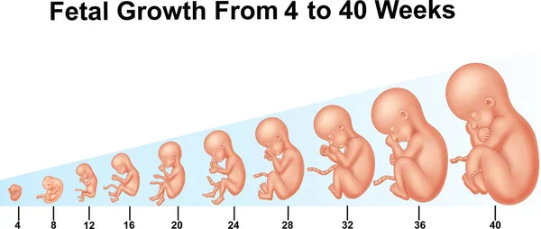

Comments:

**Conditions:**

Period allowed for completion of the task:

* 50 minutes in class to analyse second hand data and respond to questions under supervised conditions.

**Background Information:**

During gestation, the period between conception and birth, a fetus grows in size. This growth is companied by changes in its form and function or development.

**Aim**

The aim of this investigation is to graph and interpret data on fetal growth and development.

**Materials**

Graph paper

|  |  |  |  |
| --- | --- | --- | --- |
| **Time (weeks)** | **Length (mm)** | **Mass (g)** | **Developmental stages** |
| **0** | 0 | 0 | Fertilisation. |
| **1** | 0 | 0 | Embryo reaches uterus. Implantation. |
| **2** | 0 | 0 | A flat, 2-layered disc i.e. only ectoderm and endoderm. Sac-like digestive tract with no mouth or anus. Umbilical cord forming. |
| **3** | 2.5 | 0 | 3 layers present; ectoderm, mesoderm and endoderm. Beginnings of skeletal and nervous systems. |
| **4** | 6 | 0 | Simple 2-chambered heart, beating 60 beats/min. Tail, gill pouches, limb buds. Muscular system forming. Neural tube closing to form spinal cord and brain. |
| **5** | 12 | 0 | Mouth, eyes, webbed finger and toes, lungs and regions of digestive canal form. |
| **6** | 16 | 1 | Cerebral hemispheres, face, ears form. |
| **7** | 19 | 2 | Eyes open. Tail disappears. |
| **8** | 26 | 10 | All major systems formed. Now called a fetus. Ossification (replacing cartilage by bone) begins. Makes small movements, but not yet felt by mother. |
| **9** | 38 | 18 |  |
| **12** | 90 | 30 | External genital organs developed. |
| **16** | 150 | 180 | ‘Quickening’ (movement) felt by mother. Heart can be heard. |
| **21** | 300 | 450 | Heart rate 140 beats/min. Head hair appears. Skin glands produce vernix caseosa a white creamy paste to protect delicate new skin. Sleeps and wakes. |
| **25** | 350 | 875 | Vigorous movements. |
| **30** | 400 | 1425 | Testes descend. Fat deposited. Fine hair (lanugo) covers head and body. |
| **34** | 450 | 2375 | Lanugo drops away. Takes up birth position, head down usually. |
| **38** | 500 | 3250 | Full term. Skin covered with cheese-like vernix caseosa. Uterus has moved down in pelvis. Baby’s pituitary signals for birth to begin. |

**Table of Fetal Growth and Development over 38 Weeks**

1. Graph the data for foetal length and mass that appear in the table above with the graph paper provided. (5 marks)
2. During which period of pregnancy is increase in length most rapid? Include evidence from the graph. (2 marks)

_________________________________________________________________________________________________________________________________________________________________________________________________________________________________

3. During which period of pregnancy is increase in mass most rapid? Include evidence from the graph. (2 marks)

_________________________________________________________________________________________________________________________________________________________________________________________________________________________________

4. Which of the developmental changes stated in the table could cause this increase in mass during this period? (1 mark)

______________________________________________________________________________________________________________________________________________________

___________________________________________________________________________

**5.** In which trimester of pregnancy is this most crucial? Explain your reasoning. (2 marks)

______________________________________________________________________________________________________________________________________________________

___________________________________________________________________________

**6.** Outline 4 precautions pregnant women must take during their day to day consumption and exposure during pregnancy and provide an example for 2 of these. (4 marks)

______________________________________________________________________________________________________________________________________________________

______________________________________________________________________________________________________________________________________________________

______________________________________________________________________________________________________________________________________________________

7. During week 3, the three germ layers are now present. State 2 things which each germ layer is responsible for developing. (3 marks)

______________________________________________________________________________________________________________________________________________________

______________________________________________________________________________________________________________________________________________________

___________________________________________________________________________

8. Chorionic Villus Sampling (CVS) is a common foetal diagnostic method which obtains foetal cells from the chorion. State what weeks this testing may be done and why it is more advantageous than amniocentesis. (2 marks)

______________________________________________________________________________________________________________________________________________________

___________________________________________________________________________

___________________________________________________________________________

9. What affects will a deficiency of folic acid (folate) have on the foetus and what are 2 ways can the pregnant mother prevent this. (4 marks)

______________________________________________________________________________________________________________________________________________________

___________________________________________________________________________

___________________________________________________________________________

___________________________________________________________________________

___________________________________________________________________________

___________________________________________________________________________

___________________________________________________________________________

**END OF ASSESSMENT**